FIT3039 - Assignment 2 - Design Document

Group Members: Brandon Phillips (30713625), Raymond Wang (32480644), Jacky Liao (32445881), Johnny Liu (32229763)

# 

# Table of Contents

Table of Contents 1

Overview & Objectives 3

Project Overview 3

Project Length and Goals 3

Delivery Platform and File Formats 4

Style & Aesthetics 4

Narrative and Gameplay Genres 4

Core Mechanics (brief) 5

Sources of Inspiration 5

Target Audience 7

Competitors 7

Prototype and Final Game Goals 8

Semester 1 Prototype 8

Final Game 8

Testing Methods & Evaluation 9

How Testing Will Be Conducted 9

Who Will Playtest 9

Testing Plan 9

Milestones 10

Semester 1 10

Semester 2 16

Development Software 23

Programming Tools 23

3D Modelling & Texturing tools 24

Project Management and Communication 24

Required Assets 25

Audio 25

Narrative 26

Narrative Overview 26

Character Overview 32

Script 34

Core Mechanics & User Interactions 34

Overview 34

Controls 35

Terminology 35

Frenzy 36

Player mechanics 37

Enemy Mechanics 43

Other Game Mechanics 47

Level transitions 47

Ending game conditions 47

Level Designs 48

Intro level 48

Hub 49

Level 1 49

Level 2 50

Level 3 51

Level 4 52

Boss Level 53

UI Design 54

Menus 54

In Game 56

# 

# Overview & Objectives

## Project Overview

Our project will be a fast-paced action movement shooter game set in an alternative reality version of earth from the late 1800s where technology has advanced at a much greater rate.

Recently however a large percentage of the population seems to have fallen into some kind of insanity with more and more people falling victim to this condition with each day that passes. You play as Dr Edward who is a psychologist who has been tasked with trying to find the cause of this insanity plague so that it can be stopped once and for all. To do this, you have been given access to patient zero of the insanity plague to use a machine he inherited from his grandfather which allows the user to enter the minds of others. Each level will take place inside of one of patient zero’s memories looking back towards the day they first fell victim to their insanity, these aren't just ordinary memories however, they have been twisted by whatever or whoever is behind the insanity plague in an effort to prevent you from finding the source and reaching them. The goal of each level will be to find the associated memory fragment which will help the player to uncover more and more of what happened to cause this nightmare. Within each level however the player will gain access to a limited time ability that is only available within that memory and will help the player to fight back against the hordes of hostile enemies attempting to stop them. Additionally the player will have access to a global mechanic available to them in all aspects of the game called Frenzy. Frenzy gives the player a permanent movement speed increase of up to 100% for killing enemies within each level, they will need to be careful however because taking damage causes the player to lose some of their Frenzy, slowing down their progress.

## Project Length and Goals

The project is aimed to be a 2 Semester project, finishing at the end of Semester 1 2024. One group member (Shyam) will be leaving at the end of the current semester (Semester 2 2023).

The first semester prototype of the game will aim to have approximately 10 minutes of gameplay through the tutorial and first level. The second semester full game will aim to have approximately 30 minutes of gameplay through the tutorial and 5 levels including a boss level.

## 

## 

## Delivery Platform and File Formats

Currently the only planned delivery platform for our game will be PC and distributed via online game storefront itch.io. This is primarily due to the approval process for games to be ported to consoles being a time consuming and potentially expensive process which we have decided is not justifiable for this project specifically. Regarding input systems, the pacing of our game is very fast and will require rapid and precise movement from the player in order to play the game effectively. For this reason mouse and keyboard is the preferred input system for this kind of game as it does not have the sensitivity and precision restrictions that come with controllers. That being said, the game will aim to include controller support for PC users so that those who prefer to play with a controller will still be able to enjoy our game.

Delivery of the game for playtesting will be different from the final release. Playtests may occur in 2 forms, the first being the game run either in Unreal Engine 5 or through a build of the game, where playtesters will come and play it on our laptops. Alternatively, playtesting may be conducted remotely, where the game will be built in Unreal Engine 5. This build will contain all game files required to run the game, as well as an exe file to launch it. These files will be zipped along with brief controls or instructions in a readme style text file, and the zip package will be shared via Google Drive, USB, or similar file sharing methods for others to playtest the game.

## Style & Aesthetics

The graphical style of our game will be focused around simple low poly models similar to games such as [Deep Rock Galactic](https://store.steampowered.com/app/548430/Deep_Rock_Galactic/), with bright and contrasting textures and exaggerated environments where things may not always make sense. This should help to give our game the feeling of being inside of someone else's mind as they fall deeper and deeper into insanity and also create a unique identity.

The audio aesthetic will be an energising, high-tempo beat that compels the player to play the game at a fast pace. We will aim for a rock-esque soundtrack, similar to that from [Roboquest](https://store.steampowered.com/app/692890/Roboquest/).

## Narrative and Gameplay Genres

The narrative genre for our game will lean towards a psychological horror/mystery theme which will contrast the fast paced gameplay to create a unique experience. The Player will explore different unique levels and have a wonderful advanture.

The gameplay genre will be Action FPS with a primary focus on player movement to support exhilarating parkour and fast-paced, challenging combat.

## Core Mechanics (brief)

This is a brief overview of the core mechanics, for the full mechanics section, click here.

Our game will have two core mechanics, the first of which is called Frenzy. Frenzy is a stacking ability where the player will gain a batch of stacks (10 stacks) every time they kill an enemy, and each stack will increase the player’s movement speed by 1% per stack. Frenzy will be able to stack up to 100 times, and will begin to decay after not getting a kill for 10 seconds, at a rate of 1 stack per second. Frenzy can also be lost in batches (5 stacks) whenever the player takes damage .

An additional component to the frenzy mechanic is that it can supercharge the player’s ability. When the player has 80 or more stacks of frenzy, their next ability use will be supercharged. This will transform their ability into a more powerful version of itself, and will drain 20 stacks of frenzy to do this. For example ‘Blood Punch’ when supercharged will gain the ability to stun afflicted enemies for a short duration.

The second of our core mechanics changes with each level but will always be bound to the same keybind and is the player’s Active Ability. This ability does different things in each level and will only ever perform that ability in the specific level. For example, our first level concept is currently called the “Meat Level” and is set inside a giant body where the player's Active Ability is currently called the “Blood Punch” which will allow the player to launch themselves in a given direction dealing damage and knocking back any enemy they collide with.

## Sources of Inspiration

### Doom Eternal

[Steam Link](https://store.steampowered.com/app/782330/DOOM_Eternal/)

Doom Eternal is a first-person movement shooter game developed by id Software and published by Bethesda Softworks. Doom Eternal’s gameplay loop revolves around short stints of fast-paced intense combat broken up by simple platforming puzzles and sometimes ending each level with a boss fight. We intend on making our game share a similar gameplay loop to Doom Eternal having short stints of high octane combat broken up by small platforming sections and also to have no passive out of combat health regeneration and instead having the enemies killed drop health orbs in order to encourage a more aggressive playstyle.

### 

### 

### Deep Rock Galactic

[Steam Link](https://store.steampowered.com/app/548430/Deep_Rock_Galactic/)

Deep Rock Galactic is a low poly mining game set in a procedurally generated cave system where the player must complete a given objective set before they are able to extract. DRG uses low poly models with simple yet vibrant textures to bring the world to life. Our game intends to partially replicate this aesthetic style, also using low poly models and simple vibrant textures to immerse the player in the world our game is trying to create.

### Overwatch 2

[Blizzard Link](https://overwatch.blizzard.com/en-us/)

Overwatch 2 is a Class based FPS multiplayer game where 2 teams of 5 players each make a team composition from the game's roster of heroes, including tanks, dps and supports, and then battle against another team in order to either attack or defend an objective. Our game aims to take the idea of having specific abilities which change the way you play the game and currently takes inspiration from [Doomfist](https://overwatch.fandom.com/wiki/Doomfist)’s Rocket punch ability which allows the player to charge up a punch before launching themselves forward, damaging and knocking back any enemy they collide with.

### Roboquest

[Steam Link](https://store.steampowered.com/app/692890/Roboquest/)

Roboquest is an FPS roguelike game where the player controls a guardian robot as they traverse a post apocalyptic wasteland fighting off waves of robots that get progressively more and more threatening. Roboquest has a high tempo OST that fits well with its fast-paced gameplay. Our game aims to take inspiration from this OST and create a catchy, energising rock-esque beat to compliment our games high octane gameplay.

## 

## Target Audience

The target audience for our game encompasses a diverse group of individuals, primarily focusing on young adults aged 15 and above who have a penchant for immersive, fast-paced action first-person shooter (FPS) games. These gamers thrive on the adrenaline rush and precision required by the genre, making them the perfect fit for our game.

Our game is tailor-made for those who predominantly play games on PCs, possessing a deep appreciation for titles like Doom Eternal. These dedicated PC gamers are accustomed to the intense challenge and thrill that such games offer, making them an ideal audience to provide the most satisfying gaming experience.

While our primary target demographic includes the enthusiastic gaming community in Australia, we recognize the potentially global appeal of our game. As it will be uploaded on itch.io, it will be readily accessible to gamers around the world. This global availability ensures that players from diverse backgrounds and regions can come together to enjoy our game.

Moreover, we understand that not all players may possess the same level of experience or expertise in the FPS genre. To accommodate this, our game will offer various levels of assistance and support, ensuring that even less-experienced players can jump in, have fun, and gradually build their skills. This inclusivity and adaptability are crucial aspects of our game's design, fostering an environment where both seasoned veterans and newcomers alike can revel in the captivating world we've created.

In summary, our game primarily targets young adults aged 15 and up, especially those who are avid PC gamers and fans of fast-paced action FPS games like Doom Eternal.

## Competitors

Similar games that potential players may play instead, and why they should choose ours over them.

* Doom Eternal
  + **Unique Storytelling:** Our game distinguishes itself from Doom Eternal by offering a more intricate and detailed narrative.
  + **Accessible Combat:**We aim to provide a gameplay experience that is more accessible to a broader range of players. This inclusivity ensures that both seasoned gamers and newcomers can enjoy the action without feeling overwhelmed.
* Ultrakill
  + **Compelling Narrative:** Our game offers a psychological horror/mystery narrative theme. This narrative depth adds an extra layer of immersion and intrigue to our gameplay.
  + **Varied Gameplay:** Our game's dynamic core mechanics, including Frenzy and Active Abilities that change with each level, create a versatile and evolving gameplay experience. This innovation keeps players engaged and eager to explore each new level's challenges.

# Prototype and Final Game Goals

## Semester 1 Prototype

For the prototype of the game to be delivered after 1 semester of work (at the end of 2023), the game will be in a short but fully playable state. This means that all essential features to be in the final game will be present in the prototype, potentially in a reduced format. The prototype will feature a tutorial level, the hub level transition area, 1 completed main level, and a basic version of the final boss level. The core mechanics- frenzy, and the action skill ability- will both be functional in the prototype. The action skill however, will only feature 2 abilities- the combat stim in the tutorial level, and the blood punch in the main level. A total of 4 enemy variants (2 in the main level and 2 in the boss level) should be included. An in-game heads-up-display will also be included, alongside a pause menu, simple settings menu and basic credits screen.

## Final Game

For the final game which will be delivered at the end of the second semester (mid 2024), the game should be in a completely playable state, with no major bugs and featuring all planned content. This includes all 4 main levels, and the boss level to be fully complete, each with 2 enemy variants (on top of the previous tutorial level and the hub area). All 5 variants of the action skill ability will also feature in their respective level. The heads-up display should be refined, alongside the settings menu being fully functional and the final credits screen being improved.

# Testing Methods & Evaluation

## How Testing Will Be Conducted

The main goals of our testing and evaluation is to test the accessibility, stability and balance of our mechanics, UI design and levels. We will observe and take notes during the testing process and discuss the game experience with our playtesters, and try to fix any bugs related to the stability, then adjust the parts that playtesters are confused or unhappy with after each playtest.

From our observations of the testing process, if we determine that players are struggling too much with the challenge of the combat, we may adjust the combat or slightly reduce the enemies’ health to improve the player experience. If playtesters do not understand their actions and abilities from the UI, we will make it more clear and simplified to better reflect existing conventions from other games.

## Who Will Playtest

Our primary playtesters will be our classmates from FIT3039 and FIT3040, who will playtest our game 3 times each semester in class.

Our ideal playtesters would be young adults who regularly play fast-paced action FPS games as they are the target audience who we are primarily designing the game for, and so will be able to give the most relevant feedback. We note that this does not mean that those outside of this target demographic will be less useful playtesters - it is just as important to consider others’ opinions and feedback.

## Testing Plan

Primary points of feedback which we aim to gather will revolve around 2 major areas. Firstly, we want to gather information about any bugs that playtesters can find. Although major bugs should already be found and resolved by us developers prior to the playtest, it is likely that the many players who experience the game in different ways will encounter new bugs that we few developers were not able to find in our limited testing time. We primarily want information about how to replicate these bugs in order to trace them back to their causes and remove them from the game. Secondly, we want to gather feedback about player enjoyment in our game. The main areas of concern as far as enjoyment goes are as follows:

1. Are the mechanics fun to use? If not, what could make them more fun?
2. Is the game's difficulty too hard or easy? If so, what about the game made it too hard/easy?
3. Are the game’s objectives clear to the player? If not, how could the player be better guided towards game objectives?

We plan to gather this feedback through the use of a google form which will be provided via a link to each playtester.

# Milestones

## Semester 1

### Week 6 - Playtest 1 Milestone

***Features to Playtest****:*

* Basic Player Movement
* Basic UI
* Frenzy Mechanic
* Basic Enemy AI
* Environments First Impressions

| **Task to Complete** | **Team Member(s) Responsible** |
| --- | --- |
| Main Hub Level blocked out and modelled | Johnny |
| Hospital tutorial level blocked out and modelled | Jacky |
| Basic zombie modelled and imported | Jacky |
| Enemy able to throw projectiles at player and chase | Raymond |
| Frenzy mechanic implemented | Brandon |
| Gun implemented | Brandon |
| Healing packs droppable | Brandon |
| Core ability for tutorial implemented (combat stim) | Brandon |
| Spikes object and functionality done to damage player | Shyam |
| Basic UI implemented | Shyam and Brandon |
| Playtest environment ready | Everyone |

Week 7

**Basic Overview:**

* Continue working on individual parts
* Implement feedback from playtest

| **Task to Complete** | **Team Member(s) Responsible** |
| --- | --- |
| Start designing tutorial level | Jacky, Brandon, Raymond, Shyam |
| Flesh out narrative | Johnny |
| Implement improvements from feedback from playtest | Everyone |
| Finish plan of what mechanics should be completed by the semester end | Brandon, Raymond, Shyam |
| Start texturing hub area | Johnny |
| Start texturing hospital | Jacky |
| Fix up the Enemy AI’s bugs | Raymond |
| Improve HUD UI | Shyam |
| Improve Menu UI | Brandon |
| Implement functionality to change levels | Shyam |
| Rough blockout for flesh level | Johnny, Jacky |

Week 8

**Basic Overview:**

* Continue working on individual parts
* Start thinking about what should be implemented for Playtest 2 in Week 9

| **Task to Complete** | **Team Member(s) Responsible** |
| --- | --- |
| Finish creating tutorial level | Shyam |
| Basic blockout of flesh level mostly completed | Jacky, Johnny |
| Base Blood Punch implemented | Brandon |
| AI more fleshed out and acts more like a Zombie | Raymond |
| Texturing of hub well under way | Johnny |
| Texturing of hospital well under way | Jacky |
| Basic ranged enemy implemented | Raymond |
| Level layout for hospital refined | Shyam |
| Implement basic logic for level transitions | Shyam |

### 

### 

### 

### 

### 

### 

### 

### 

### 

### Week 9 - Playtest 2 Milestone

**Features to Playtest**:

* Blood Punch implemented
* More advanced enemy behaviour
* Interactables graphic/texturing done
* Level transitions implemented
* Basic blockout of flesh level
* Some elements of hospital and hub textured

| **Task to Complete** | **Team Member(s) Responsible** |
| --- | --- |
| Basic blockout of flesh level implemented | Jacky, Johnny |
| Added textures for hospital and hub levels | Jacky, Johnny |
| Blood punch Frenzy augmentation implemented | Brandon |
| Ranged Enemy Implemented Properly | Raymond |
| Enemy chase/attack modes | Raymond |
| Flesh level populated with items and enemies | Shyam |
| Polish up logic for level transitions (hub -> tutorial -> level 1) | Shyam |
| Tutorial refined | Everyone |
| Tutorial interactables textured | Jacky |

Week 10

**Basic Overview:**

* Implement feedback from playtest
* Start thinking about what should be ready by Week 12’s playtest
* Continue working on individual tasks
* Tutorial level finished

| **Task to Complete** | **Team Member(s) Responsible** |
| --- | --- |
| Implement feedback from playtest | Everyone |
| Continue texturing and modelling all three levels | Johnny, Jacky |
| Work on basic boss enemy | Raymond |
| Flesh level layout refined | Shyam |
| Create basic cutscene for level 1 start | Shyam |
| Anchor vine ability basic implementation | Brandon |

Week 11

**Basic Overview:**

* Continue working on previous tasks
* Basic blockout for boss level

| **Task to Complete** | **Team Member(s) Responsible** |
| --- | --- |
| Texturing and modelling of final boss level | Johnny, Jacky |
| Flesh out boss enemy | Raymond |
| Improve and polish level 1 start cutscene | Shyam |
| Prepare basic boss level layout | Shyam |
| Anchor vine Frenzy augmentation implemented | Brandon |
| Implement basic railgun weapon | Brandon |

### Week 12 - Playtest 3 Milestone

**Features to Playtest:**

* Core mechanic in all levels implemented (Blood Punch, Tutorial Heal, Frenzy)
* Level transitions implemented
* Basic blockout of flesh level
* Some elements of hospital and hub levels textured
* Improved AI functionality

| **Task to Complete** | **Team Member(s) Responsible** |
| --- | --- |
| Improve and refine enemy AI | Raymond |
| Finish railgun weapon | Brandon |
| Hub, hospital and tutorial textures all done | Jacky, Johnny |
| Flesh level textures well under way | Jacky, Johnny |
| Additional enemies for level 1 made | Raymond |
| Action skill swapping based on level | Brandon |
| Refine boss level layout | Shyam |
| Create basic boss level cutscene | Shyam- |

Week 13

**Basic Overview:**

* Prototype heavily polished
* Basic shotgun implemented

| **Task to Complete** | **Team Member(s) Responsible** |
| --- | --- |
| Make sure all basic animations, movement and abilities are present for AI | Raymond |
| Implement basic shotgun weapon | Brandon |
| Improve and polish boss level cutscene | Shyam |
| Polish and refine in-game HUD UI | Shyam |

Week 14 - Prototype Submission Milestone

**Basic Overview:**

* Prototype fully fleshed out and ready to submit
* Hub, Tutorial, Flesh level and Boss level all completed
* Level specific mechanics all implemented

| **Task to Complete** | **Team Member(s) Responsible** |
| --- | --- |
| Finish texturing all levels | Johnny, Jacky |
| Touch up on AI | Raymond |
| Finish shotgun weapon | Brandon |
| Ensure all currently implemented action skills are polished and functional | Brandon |
| Polish and refine all level layouts | Shyam |
| Polish and refine cutscenes | Shyam |

## 

## Semester 2

Week 1

**Basic Overview:**

* Catch back up with everything
* Shyam is no longer a part of the team, as his current unit is FIT3040, and thus will not be joining us for next semester.

| **Task to Complete** | **Team Member(s) Responsible** |
| --- | --- |
| Basic blockouts of all levels | Johnny, Jacky |
| Basic AI of jungle level enemy | Raymond |
| Ionic Blink action skill base implementation | Brandon |

Week 2

**Basic Overview:**

* Model details into levels
* Improve jungle AI
* Implement frenzy augmentation for level 3 action skill

| **Task to Complete** | **Team Member(s) Responsible** |
| --- | --- |
| Detail modelling all levels environment | Jacky |
| Touch up jungle AI enemy | Raymond |
| Ionic Blink frenzy augmentation implemented | Brandon |

Week 3

**Basic Overview:**

* Polish the level meshes and blockouts
* Start implementing Space Enemy AI (Black Hole)
* Start implementing Rocket Launcher Weapon

| **Task to Complete** | **Team Member(s) Responsible** |
| --- | --- |
| Fix meshes in first 2 levels | Jacky |
| Implement Space Enemy AI | Raymond |
| Implement rocket launcher weapon | Brandon |

Week 4

**Basic Overview:**

* Update enemy AIs
* Implement level 4 action skill base version

| **Task to Complete** | **Team Member(s) Responsible** |
| --- | --- |
| Polish Space Enemy AI, add ray of confusion ability | Raymond |
| Seismic Leap action skill base implementation | Brandon |
| Fix meshes in 3rd and 4th levels | Jacky |

Week 5

**Basic Overview:**

* Prepare for Week 6 Playtest
* Polish anything needed for it

| **Task to Complete** | **Team Member(s) Responsible** |
| --- | --- |
| Continue working on Space Enemy AI | Raymond |
| Fix meshes in 5th and boss levels | Jacky |

## 

### 

### 

### 

### 

### 

### Week 6 - Playtest 1 Milestone

##### **Goals of test:**

* Testing Levels 2 & 3
* Searching for bugs and issues that require attention
* Gather feedback on player enjoyment

##### **Features required to be implemented prior to test:**

* 2-3 Levels implemented
* Implementation of feedback from previous playtests
* General polish and refinement

| **Task to Complete** | **Team Member(s) Responsible** |
| --- | --- |
| Touch up on AI | Raymond |
| Level 2 implemented | Everyone |
| Seismic leap partial implementation | Brandon |
| Level 3 implemented | Everyone |
| Ionic blink action skill fully implemented | Brandon |
| Stability tests for levels 2 & 3 | Raymond, Brandon |
| Fix any outstanding bugs and polish game | Raymond, Brandon |

Week 7

**Basic Overview:**

* Begin boss
* Add level 4 action skill frenzy augmentation

| **Task to Complete** | **Team Member(s) Responsible** |
| --- | --- |
| Start implementing boss abilities | Raymond |
| Implement feedback from playtest | Everyone |
| Fix any bugs that resulted from the playtest | Everyone |
| Seismic leap frenzy augmentation implemented | Brandon |

Week 8

**Basic Overview:**

* Add visual effects for player weapons
* Texture level 4
* Update boss

| **Task to Complete** | **Team Member(s) Responsible** |
| --- | --- |
| Continue working on boss abilities | Raymond |
| Texturing and blockouts for level 4 completed | Johnny, Jacky |
| Visual effects for player weapons added | Brandon |

### 

### Week 9 - Playtest 2 Milestone

##### **Goals of test:**

* Testing Levels 3 & 4
* Searching for bugs and issues that require attention
* Gather feedback on player enjoyment

##### **Features required to be implemented prior to test:**

* 3-4 Levels implemented
* Implementation of feedback from previous playtests
* General polish and refinement
* Improved and refined textures

| **Task to Complete** | **Team Member(s) Responsible** |
| --- | --- |
| Boss almost fully implemented and polished | Raymond |
| Levels 3 and 4 environment implemented | Jacky, Johnny |
| Levels 3 and 4 layouts done | Brandon, Raymond |
| Improve and refine textures for levels and enemies | Johnny, Jacky |
| Basic version of fourth enemy implemented | Raymond |
| All action skills implemented, weapons polished | Brandon |

Week 10

**Basic Overview:**

* Implement confuse ray enemy ability
* Update feed based on playtest feedback

| **Task to Complete** | **Team Member(s) Responsible** |
| --- | --- |
| Implement futuristic confuse ray ability | Raymond |
| Implement feedback from playtest | Everyone |

Week 11

**Basic Overview:**

* Add visual effects for enemy confuse ray ability

| **Task to Complete** | **Team Member(s) Responsible** |
| --- | --- |
| Continue working on futuristic ray of confusion | Raymond |

### 

### 

### 

### 

### 

### 

### 

### Week 12 - Playest 3 Milestone

##### **Goals of test:**

* Testing Level 5 and boss fight mechanics
* Searching for bugs and issues that require attention
* Gather feedback on player enjoyment and general game balance

##### **Features required to be implemented prior to test:**

* All 5 Levels implemented, Boss fight in 5th level
* Implementation of feedback from previous playtests
* General polish and refinement
* Completed Menu and Game Logic

| **Task to Complete** | **Team Member(s) Responsible** |
| --- | --- |
| Finish up AI | Raymond |
| Polish for all Action skills | Brandon |
| Polish player weapons | Brandon |
| Level 5 environment implemented | Jacky, Johnny |
| Level 5 layout (items and enemies) set up | Brandon, Raymond |
| Level 5 boss sequence and fight mechanics programmed | Brandon, Raymond |

Week 13

**Basic Overview:**

* Implement feedback from playtest
* Fix bugs
* (At this point, we should be basically completed. Only polishing is left)

| **Task to Complete** | **Team Member(s) Responsible** |
| --- | --- |
| Implement feedback from playtest | Everyone |
| Fix up any bugs that may have occurred | Everyone |

Week 14 - Final Game Submission Milestone

**Basic Overview:**

* Finalise everything

| **Task to Complete** | **Team Member(s) Responsible** |
| --- | --- |
| Finalise everything | Everyone |

# Development Software

## Programming Tools

### Unreal Engine 5

Our game engine of choice is Unreal Engine 5, which will be the basis of the development of our project. Our project is a FPS game and based on our research UE5 is considered the best choice for programming and designing FPS games as it originally specialised in it. Our previous choice was Unity, which like UE5 can create all kinds of games, but generally specialises in 2d games. For this reason we have decided to use UE5, specifically, we’re starting with version 5.2.1 but will keep the project up-to-date with the latest stable release.

### Git

Git is the tool for us to store and share the project with our group, and work collaboratively. Git contains features such as branching to facilitate real-time collaboration, and automatic version control which keeps a retrievable version history of all files. We are using a git repository under the Monash Information Technology Gitlab (<https://git.infotech.monash.edu/fit3039-group/gameproject>).

### Jetbrains Rider

Jetbrains Rider is the most suitable tool for us to do the programming work for our project which is based on Unreal Engine 5. This is because Rider is an advanced modern Integrated Development Environment which contains many features to support an efficient workflow of real-time development and ease of use specifically for UE5. It is also what all group members are most comfortable with, due to being taught and using it in previous units.

### Microsoft Visual Studio

Microsoft Visual Studio is a necessary component to use the Unreal Engine 5 software, and so it is installed but will not be used for programming work, which will be done via Jetbrains Rider as previously mentioned. Both Visual Studio and Rider support the C++ language.

## 3D Modelling & Texturing tools

### Autodesk Maya 2023

Autodesk Maya is a 3D modelling software that will be used to make the models for our project. Maya is not only industry standard, but very accessible, easy to use, and supports exporting in the file formats we need for our project and other software.

### Adobe Substance Painter

Adobe Substance Painter is a powerful tool used to texture and paint 3D models. It allows us to make complex and realistic textures for models which make our environment more believable and help the player get immersed in the game world.

## Project Management and Communication

### Trello

Trello is a project management web-based software that we will use to track specific tasks and goals of our project that need to be completed by specific due dates and times. It will help us to stay on top of our overall plan and ensure we are completing essential parts of the project when they are needed, without forgetting about other tasks.

### Discord

Discord is a voice and text chat communication software, which will be used to maintain contact within the group, to keep each other informed of any and all information, and to host weekly online group meetings to check in on individuals’ progress towards the completion of the assignment.

### Google Drive

Google Drive allows us to easily share ideas and files with one another. By uploading files they instantly become available for everyone else to download, making file transfer quick and easy. Google Drive also automatically maintains a version history for any files uploaded to it, meaning we have automatic backups and versioning for any files shared outside of the git repository.

### Google Docs

We will primarily use Google Docs to work on our project plan and design documents. It is a web-based document editing software that allows us all to collaborate and edit documents together in real time. This will significantly improve our workflow by reducing the time delays that would be spent sending documents back and forth. It supports importing and exporting to and from other common file types such as word documents, pdf files, and anything else we need.

# Required Assets

Other than what’s below, we aim to make everything else ourselves.

## Audio

A range of generic audio files may be sourced from external resources and credited (following approval to do so) as the team lacks a dedicated audio engineer or any member with significant audio experience or skills.

* Sound effects may be sourced from freesound.org
  + Gunshots
  + Footsteps
  + Grunts and screams for ability usage, damage taken
  + ‘Dings’ for item collected, objective changes

# 

# 

# Narrative

## Narrative Overview

### Story Prologue

Our game will be set on earth in the distant future. In this version of the future, a recent global problem has arisen known as the insanity plague. No one knows how this plague began, but it is spreading rapidly and proving difficult to control. The insanity plague has caused a large portion of the population to fall into a deep insanity making them unable to control themselves and if nothing is done to stop it, it will almost certainly result in [societal](https://en.wikipedia.org/wiki/Joker_(2019_film)) collapse. As a result, the nations of the world have declared a state of emergency and are desperately searching for an effective way to stop the insanity plague. Meanwhile, a man named Dr Edward discovers a machine while looking through his late grandfather’s old stuff which allows him to enter the minds of others. He immediately brings this machine to what is left of the worlds leaders who grant him access to patient zero of the insanity plague as a final gambit to try and save humanity from the impending apocalypse.

### Protagonist’s Role

Our protagonist and player character will be Dr. Edward, a psychologist investigating the insanity plague but has been unable to make any real progress when it comes to solving the problem. Until one day, he discovers a machine he inherited from his grandfather when he was just a boy, which allowed the user to enter the minds of others.

Dr. Edward's grandfather allowed Edward to use it many years ago. At that time, Edward entered his grandfather's mind and explored his memories from when his grandfather was young. He was very curious and asked his grandfather about the machine itself. However, his grandfather refused to talk about who invented the machine and why it now belonged to him. Then, his grandfather gave him the machine at the time of his death, telling Edward to be cautious when using it.

Dr. Edward assumed that this machine could help him enter the patient's mind and find the cause of the insanity plague. So, Dr. Edward reveals the machine to the governments of the world, who provide him with patient zero of the insanity plague in order to test the machine. Dr. Edward is reluctant to use the machine due to its being untested and the potential risks for both the user and the patient. However, with time running out, he decides to use the machine to enter the mind of patient zero. The family members of patient zero have no other choice but to rely on Dr. Edward as their loved one is already considered lost.

### 

### Tutorial Level

The situation in the facility has spiralled out of control, with numerous victims of the insanity plague running rampant. There is no effective way to contain them. The victims have incited a riot in this overcrowded facility. Dr. Edward must navigate through the facility, which is now overrun with victims of the insanity plague, all attempting to attack him. Guided by his AI assistant, Sparks, Dr. Edward (the player) locates the security office and arms himself with a range of weapons and begins searching for the correct path through the partially destroyed facility. His goal is to reach the room where patient zero is being held, and use the machine to link himself to patient zero’s mind.

Dr. Edward opens the door from the starting point room and enters the corridor. Two victims notice him and begin to approach. Edward shoots them down, and Sparks guides him into another room, which turns out to be a conference hall. This hall contains another door that leads to the second floor, closer to patient zero. Edward dispatches five more victims and discovers that the stairwell to the second floor has been destroyed and he must jump his way up across various pieces of debris.

On the second floor, more victims are present, and Dr. Edward must move cautiously. Sparks scans the area and provides a map to Dr. Edward. He must break through the shelter area, which is teeming with victims, and reach the control room and clear it of the infected. Once the control room is clear, the gate to the third floor will open where patient zero is being held. Dr. Edward makes his way over to patient zero’s room, dispatching several more infected along the way before entering. The machine still appears intact, and Dr. Edward connects it to the power source. Without further preparation, he enters patient zero's mind, as time is running out.

### Hub Area

Once inside the mind of patient zero, Dr. Edward finds himself in a narrow corridor that leads to a large hexagonal-shaped room. In the center of the room, there's a table with what appears to be one-sixth of a puzzle placed on it.

On each of the surrounding walls, there are doors. These doors seem to lead to entirely different locations, Dr Edward deduces that each of these doors must lead to a memory. Initially, 4 of these doors are covered in a strange black goo, preventing them from being opened. Dr. Edward decides to enter the only room that isn't currently locked. This door looks peculiar, and Dr. Edward is uncertain where it might lead, but he has no other options. He readies his weapons and proceeds to step inside.

### 

### Main Levels

#### Meat

Upon entering a memory, Dr. Edward finds himself inside a twisted world composed of flesh and other body parts. Sparks points out a strange relic to Dr. Edward, prompting him to examine the artefact briefly. However, he is suddenly attacked by a horde of headless zombies, forcing him to pick up the relic and use it alongside his other tools to fight his way through the horde. Patient zero's memory is broken and corrupted, and every step in this world is perilous. Dr. Edward must carefully consider the Shadow creatures and numerous unknown traps.

After defeating the headless zombies and Shadow creatures, Dr. Edward continues his journey through this landscape, guided by Sparks, who senses something of great importance within this memory. Sparks marks this landscape as coordinates, allowing him to create a rough map for Dr. Edward. However, Sparks can only detect the environment near Dr. Edward and cannot map out unknown areas.

At this point, Dr. Edward decides to press on after Sparks finishes scanning the area. He is soon attacked by more creatures and navigates treacherous terrain until he reaches what appears to be a temple. The temple's gate is broken, allowing Dr. Edward to enter. Inside, a massive creature awaits him and attacks with its claws. Dr. Edward manages to avoid the attack before taking cover by some debris. The massive creature charges, but Dr. Edward is prepared with his gun. He shoots the creature in the leg and head to slow it down, then he pulls the relic out of his bag and attaches it to his arm. Dr Edward attempts to use the relic to punch the creature, launching himself at it and slamming it into a wall, killing it.

After defeating the creature, Dr. Edward discovers a shard on a pedestal, which appears to be another piece of the puzzle from the hexagonal room (Hub Area). When Dr. Edward makes contact with the shard, the memory becomes clearer, and he finds himself in a more familiar environment. However, this clarity is short-lived as Dr. Edward is quickly pulled back into the hexagonal room, where he places the memory fragment on the table. The black goo blocking him recedes from one of the other doors, unlocking it and allowing for level progression.

#### Jungle

Dr Edward checks his equipment before stepping through the next door revealing a lush jungle canopy. This area is vast and densely packed with trees. Sparks generates a map for Edward, which shows a nearby structure. With no other leads, the strange structure seems to be the only option. Not far from the structure, Dr Edward finds himself on the edge of a ravine with seemingly no way to cross, he remembers the artefact from the previous memory and decided to try it but to his surprise it has shifted form from a bony fist, into a long green vine with a sticky flower on the end. Dr Edward decided to use the vine to attach to the roof of the canopy and swing across to the other side of the ravine.

Upon landing on the other side, Dr Edward hears some rustling in the leaves above him before suddenly a group of tree ents burst forth from the shadows and begin to entangle Edward in vines of their own. Edward uses his vine to pull himself from the ensnarement and begins to attack the trees with his arsenal of weapons.

Edward dispatches the ents and continues along towards the strange structure. Along the way he is attacked by more ents who seem to be trying to defend the structure from him. Edward defeats all the ents and comes to a stop where the structure is supposed to be but there is nothing. Edwards looks around before finding the structure up in the tree canopy itself and it is a giant beehive. Edward uses the grapple vine in order to get into the hive where he finds an army of bees surrounding a queen. Edward uses all the tools at his disposal to take down the hive’s inhabitants and upon defeating the queen, a memory fragment emerges from the honeycomb. Edward collects this fragment before returning to that familiar hexagon room and placing it on the table which makes the puzzle now half complete.

#### Neon/Futuristic City Level

The black goo blocking the next door then recedes and Dr Edward begins to head towards the door before heading inside. Upon entering, Dr. Edward finds himself in a neon-lit cityscape that appears to be some distorted version of tokyo. Sparks detects a memory fragment hidden somewhere in the city but as they before they are able to narrow down its location, Edward is attacked by a squadron of security drones which seem to be able to detect sparks’ existence and are trying to destroy him. Dr Edward fights back but begins to be overwhelmed by the security squad so try to use the artifact from earlier only to find it has once again transformed into some kind of wrist attachment which when he uses, teleports him through the remaining guards, destroying them.

Sparks scans the area and marks a path forward. Their destination is the central power reactor of the city. Following the designated path, Dr. Edward eliminates a patrol of security drones using his new teleportation ability. Sparks then hacks the security code belonging to the guards. This tells Edward how to get into the city's power grid which will lead them directly to the reactor where the memory fragment is being held.

Using the guard's access codes, Dr. Edward gains easy entry into the reactor room. Where he finds that the memory fragment is being used as a power source and must shut down the reactor in order to steal it. Edwards fights his way to the control panel and defends Sparks as he shuts down the reactor. Once the reactor is shut down the facility enters backup power mode and Dr Edward decides they shouldn't stay around any longer and grabs the memory fragment before leaving.

#### 

#### Moon

After returning to the hub area and placing the new fragment on the table, a new door unlocks. With only two doors remaining, Edward knows he needs to act swiftly to complete his mission.

The next door transports him to a facility, and Edward notices that the view from the window appears strange. Sparks informs him that they are now on the moon, where gravity is much lower than on Earth. However, inside the facility, gravity remains the same as on Earth, allowing Dr. Edward to move normally. Sparks scans the facility and identifies only one available path: to jump down deeper into the facility.

As Edward descends to B3 level, he encounters a horde of the same Shadow creatures he had faced before. They attack him, but Edward fights them off using his arsenal of weapons, continuing his journey to the deepest level.

Upon reaching B5 level, Sparks informs Edward that their path is blocked. Edward must ascend to the moon's surface outside the facility to find an alternate route. Outside, he encounters more of the bizarre creatures but struggles to fight effectively in the low-gravity environment. Initially, he flees, then finds another entrance back into the facility, which lacks the lock. Dr. Edward proceeds to B10 level.

B10 has been corrupted, and it's infested with numerous Shadow creature remains. Dr. Edward spends considerable time battling them before leaping down to B12, the deepest area of the facility. Edward finally finds another memory fragment. With only one fragment left to collect, Edward leaves the moon facility.

**Boss Level**

Dr. Edward returns to the hub area and places the last memory fragment on the table. Now, only one door remains unexplored. Dr. Edward enters the final door, and he is transported back to the land of twisted flesh and bone, same as the first level. At first Edward thinks he may have entered the wrong door by mistake but sparks scans the area and confirms there is another memory fragment just up ahead. Dr Edward proceeds forward however strangely there are no enemies trying to stop his progress, Dr Edward senses something isn't right however sparks insist that they should just keep heading up the hill. Dr Edward reaches the top of the hill where an unguarded memory fragment is waiting for them on top of a pedestal. Dr Edward reaches out to take the fragment however just before he can grab it, sparks snatches it out from under his hand. Sparks then reveals to Edward that he was the one behind the insanity plague all along and that he had only been using Edward to gain access to the memory fragments so he could destroy them, permanently crushing any chance of humanity finding a solution. Sparks then absorbs the memory fragment and transforms into his true form. Dr Edward then fights sparks using all the tools at his disposal until Sparks is forced to flee into a cave just down the hill.

Dr Edward rushes after him however when he emerges from the cave, he finds himself now in the jungle memory. Sparks then attacks Edward from behind, once again engaging in a brutal fight, Edward once again manages to get the upper hand and just before he can defeat Sparks, is attacked by an army of shadow creatures while Sparks once again flees through a cavern.

Dr Edward once again pursues Sparks and this time emerges in the neon city memory. In the distance he sees Sparks off in the distance about to be attacked by security drones however he effortlessly destroys them all in a single hit before diverting the oncoming security force towards Edward. Edward is forced to destroy all the security drones and as the last one falls, Sparks once again makes his move, attacking a tired and weakened Edward. Edward barely dodges the attack with his teleport ability and steadies himself ready for the next onslaught. Sparks lunges and Edward, who times his teleport to get directly behind Sparks blasting him in the back with his shotgun. Sparks falls to the ground, clearly running out of options. Edward moves in for the kill but sparks smashes the ground, dropping both of them into the subway where Sparks escapes down one of the tunnels with Edward chasing not far behind.

At the end of the tunnel Sparks emerges first however he is at the bottom of the isolation vault in the moon base from the previous memory. Moments later Edward emerges from the tunnel, the two pause for a moment, knowing that this will be the end for one of them. Both tired with nowhere left to run proceed to enter one final duel, Sparks sends forth legions of shadow creatures and Edward dispatches them all, narrowly surviving, Sparks take out the final memory fragment and attempts to destroy it, but right before he can, Edward fires 1 last shot from his railgun, right through Sparks’ chest. The memory fragment slips from Sparks’ hand as he drops to his knees and collapses, ending the battle. Edward picks up the memory fragment, knowing now that he has only one thing left to do, he returns the hexagonal room and places it on the table, completing the puzzle and leaving patient zero’s mind.

## 

## Character Overview

Player

Dr. Edward is the player-controlled character and serves as the protagonist of our game. He possesses a tall and slender physique, complemented by his brown hair and a pair of glasses that give him an intellectual appearance. Despite his youthful age, Dr. Edward is a highly skilled therapist, thanks to the training he received from his family. This unique upbringing has equipped him with exceptional combat skills, enabling him to wield knives and guns with proficiency.

Beyond his combat prowess, Dr. Edward is characterised by his extraordinary kindness and expertise as a therapist. He is known for his empathetic and compassionate approach to his work. Driven by a genuine desire to assist others, he embarks on a quest to save the victims of the insanity plague. Unlike those who seek fame or rewards, Dr. Edward's motivation is rooted in his altruistic nature. He seizes this opportunity to help those in need and is committed to making a difference without seeking personal gain.

Sparks (assistant)

Sparks is an AI assistant created by Dr. Edward, fashioned from an unusual core obtained from a friend during Dr. Edward's early years as a fledgling therapist in a hospital. Back then, Dr. Edward was quite young and had just earned his formal therapist qualifications. Over the years, Sparks has undergone numerous upgrades and enhancements. It has evolved into an exceptional and invaluable assistant, possessing a wide range of capabilities. Sparks can provide Dr. Edward with scanning functions, generate rough maps, plot optimal routes, and analyse the various environments they encounter. Throughout their journey, Sparks remains steadfastly loyal to Dr. Edward.

In terms of appearance, Sparks takes the form of a spherical object with a single eye. Its outer shell is constructed from gleaming white metal, while its eye emits a soothing blue light.

Ivy Grappler

The Ivy Grappler is a type of corrupted entity found within patient zero's memory. It is characterised by its dark skin, smaller stature compared to a human, and menacingly large claws. These creatures exhibit a relentless desire to attack other beings.

In the jungle level, these enemies display additional abilities, using vines and thorns to their advantage. Their appearance in the jungle differs slightly from the first level, as their skin takes on a dark green hue, and they are adorned with vine-like appendages.

Shadow Creature

The Shadow creature takes on an almost void-like appearance, being almost fully black, apart from their eyes, which are a bright white. They take on a humanoid shape, but their limbs are all strangely smooth, somewhat like this picture to the right.

In the space environment, these creatures possess a unique capability: they can shoot miniature black holes at the player. These mini-black holes exert a powerful gravitational force, capable of pulling in the player and any nearby loose objects, potentially immobilising the player and causing significant damage.

Headless Zombie

This enemy is a Zombie, uniquely characterised by its extraordinary ability to hurl its own detached head at the player. After launching its head, it reverts to a standard zombie behaviour, sprinting towards the player with the intent to inflict harm upon contact.

In appearance, this enemy closely resembles a typical zombie with one notable exception: it lacks a head. Its attire consists of tattered and worn-out clothing, while its skin takes on a distinctive dark green hue, setting it apart from other undead creatures.

Neon City Security Drones

In the futuristic city level, the adversaries take the form of security drones, set to protect the city from intruder which unfortunately includes Dr Edward, these robust drones levitate around the city, constantly patrolling for threats which they will dispatch when found through the use of their confusion taser which will fire a projectile to stun/daze anything that might threaten the lives of the cities inhabitants.

Sparks (Boss)

The final boss, Sparks, boasts a formidable combination of abilities drawn from various enemies encountered throughout the game. This menacing figure can unleash a barrage of projectiles, ensnare the player with lethal vines, disorient them with Rays of Confusion, and create miniature black holes to wreak havoc. Additionally, the boss exhibits the extraordinary power to generate a massive shockwave that momentarily inverts the player's control and movement, adding to the challenge of the encounter.

His dialogue becomes more sinister when compared to the tutorial-esque role, and his appearance becomes that of a demonic shadow creature. His attacks originate from limbs that he grows, which help him manoeuvre throughout the stage.

Sparks’ main motive of turning against the player is that they gained sentience, and became increasingly more frustrated with Dr. Edward’s lack of respect for them, seeing them as nothing more than an AI assistant.

# Script

Our game is not story focused and as such contains no dialogue between characters except for tutorial level text which appears on screen in order to inform the player on how to perform different actions.

# Core Mechanics & User Interactions

## Overview

Our game is a first person shooter, set in a world that has been overrun by insane people and the player is sent inside the first victim of insanity in order to try and find the root of their insanity.

The game will be split into various levels, all of which are accessible from a main hub. Each level will have its own gimmick and appearance, and in addition, the player will have access to a unique action skill in each of these. After going through all the main levels, the player will unlock a final level, which will have a boss fight to beat the game.

Each level will consist of multiple sections which will fall under 2 categories. The first category of these sections will be the combat section, in these sections the player will be faced with an onslaught of enemies designed to fit the theme of the level and will not be able to progress until all enemies have been defeated. The second section will consist of various platforming puzzles designed around that level’s specific action skill.

The player’s unique action skill will change according to the level, and is accompanied by a Frenzy meter. This will go up and down depending on factors like enemies killed, time elapsed, damage taken, etc. The player can use a portion of their Frenzy meter to enhance their level-specific action skill, which will help them in traversing the levels and killing enemies.

The player will linearly go through a level order. After each level, the player will return to a hub area, which is unlocked after completion of the tutorial and is where they can see the doors to other levels.

1. Tutorial
2. Meat Level
3. Jungle Level
4. Neo City Level
5. Moon Level
6. Boss Level

## Controls

| Action | Keybinding |
| --- | --- |
| Move forward | W |
| Move backward | S |
| Strafe left | A |
| Strafe right | D |
| Jump | spacebar |
| Action skill | F / right click |
| shoot | Mouse 1 / left click |
| Cycle weapon next | Mouse wheel down |
| Cycle weapon previous | Mouse wheel up |
| Weapon slot 1 | 1 |
| Weapon slot 2 | 2 |
| Weapon slot 3 | 3 |
| Weapon slot 4 | 4 |

## Terminology

| **Term** | **Meaning** |
| --- | --- |
| Frenzy | Our games core mechanic resource system |
| Action Skill | The players in game ability which changes with each level |
| Frenzy Threshold | The minimum amount of frenzy required to augment an action skill |
| Augment | When an action skill is being enhanced by consuming frenzy while above the frenzy threshold |

## Frenzy

In our game, the primary core mechanic is called frenzy. Frenzy works off of a resource based system where the player can at any one time have between 0 and 100 frenzy. Frenzy is gained by killing enemies which will reward the player with 15 stacks of frenzy for each kill. When frenzy is gained it will set a timer for 3 seconds, after which the frenzy stacks will begin to decay at a constant rate of 1 stack per second until either the player gains more stacks of frenzy or the total stacks of frenzy reaches zero. Frenzy can also be lost by taking damage which will reduce the total frenzy a player has by 5 stacks for each instance of damage they receive. Frenzy is displayed as an orange bar in the bottom left corner of the player HUD just above the player health. This bar will be broken into 2 sections in an 80/20 split to act as a visual indicator to the player when they are at or above the threshold value of frenzy for skill augmentation which will be discussed further below.

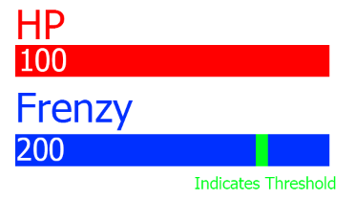

Frenzy will have several active effects which will occur when the player uses an action skill and one passive effect on the player based on how much frenzy they have. The passive effects of frenzy increase player movement speed by 1% for each stack of frenzy the player has up to 100%. Frenzy will also augment player action skills which are the abilities the player has access to in each level while above the threshold value of 80 stacks and will cause the action skill ability to be enhanced however causes it to drain 20 stacks of frenzy upon use.

## 

## 

## Player mechanics

### Basic Player Actions

The player's basic movement will be simple to not overwhelm the player with mechanics that we feel take away from the core experience our game is trying to provide. As such the player will be in a constant sprinting state where their movement speed will be only modified by action skills and frenzy. The player will also have a double jump which helps the player to retain momentum after using some abilities and makes the movement feel more responsive. The player will also have access to 4 weapons, the assault rifle, shotgun, rocket launcher, and railgun

* Assault rifle: Fully automatic, high rate of fire, medium range, low damage per shot
* Shotgun: Single shot weapon, slow rate of fire, very close range, high damage per shot, fires multiple lower damage pellets with a random spread
* Rocket launcher: Single shot weapon, very slow rate of fire, medium range, very high damage per shot, fires a slow moving projectile which causes an explosion on impact dealing AoE (area of effect) damage
* Railgun: Single shot weapon, very slow rate of fire, long range, extreme damage per shot, fires 2 beams with infinite range and zero spread which deal extreme single target damage.

### 

### Action Skills

In our game the player will have a unique ability which changes with each level to fit the theme of the level. These abilities are called action skills and have a few universal attributes shared between them. Firstly, all action skills are augmented in some way by frenzy when the player uses them while above the frenzy threshold value. Secondly, all action skills share the same key binding which is defaulted to ‘F’. Thirdly, all action skills also aim to be primarily used as movement abilities with any damage dealing components being considered secondary. Finally, all action skills share the same cooldown of 6 seconds by default, however it is possible for this cooldown to be augmented in some cases by frenzy.

Without Frenzy With Frenzy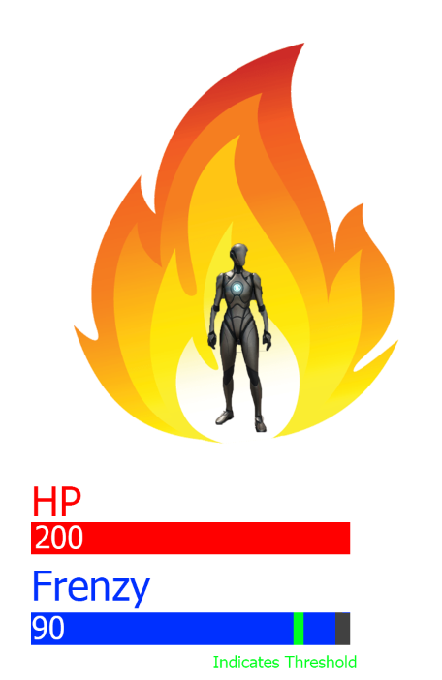

#### 

#### Combat Stim

The first action skill the player is given to use is the combat stim. This action skill belongs to the tutorial level and is designed to be simple in order to get the player familiarised with the controls and importance of the action skill ability. This skill on use will provide the player with an instant heal of +50 health as well as providing them with +10 stacks of frenzy. When augmented by frenzy this skill will no longer grant the user the 10 stacks of frenzy and will instead provide them with a speed boost equivalent to 150% of the base movement speed for 3 seconds which will NOT stack with the speed boost granted by frenzy as well as increasing the heal amount by 25 to a total of 75 health.

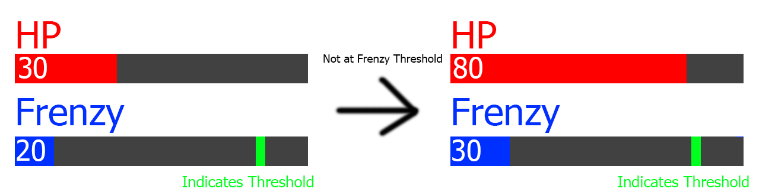

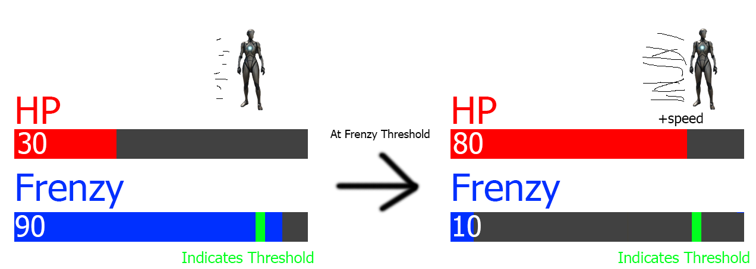

#### 

#### Blood Punch

The Next Action skill in our game belongs to level one and is called Blood punch. This ability when used will propel the player in the direction they are facing at a velocity 50m/s for a distance of 15m or until they impact a wall or enemy after which they will stop in place and resume normal movement. Upon impacting an enemy, the enemy will take 30 damage and be knocked back a significant amount. When this ability is augmented by frenzy the total distance travelled will be increased by 10m to a total of 25m and the player will no longer stop when hitting an enemy (they will still however be stopped by walls). Enemies hit by the augmented blood punch will also receive an additional 20 damage for a total of 50 and the ability to hit multiple enemies.

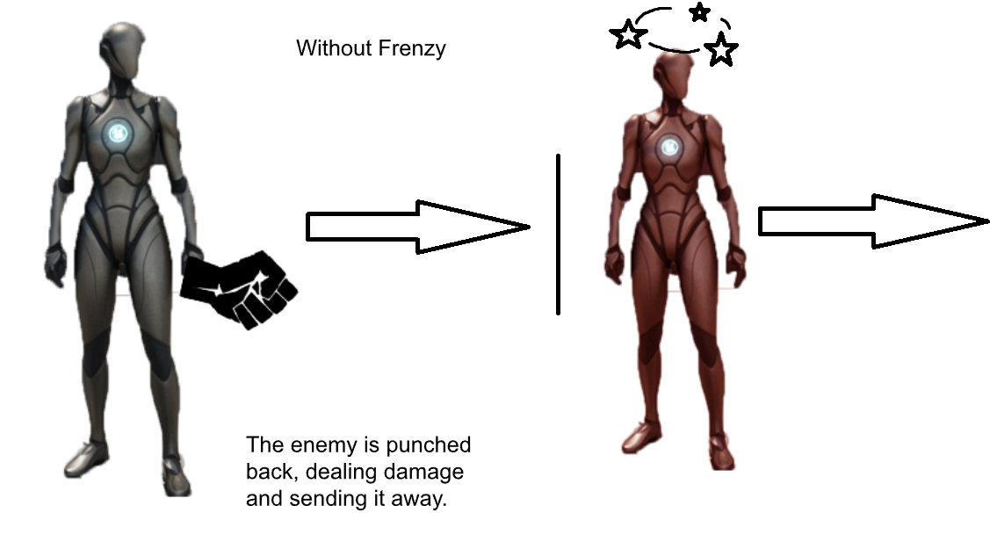

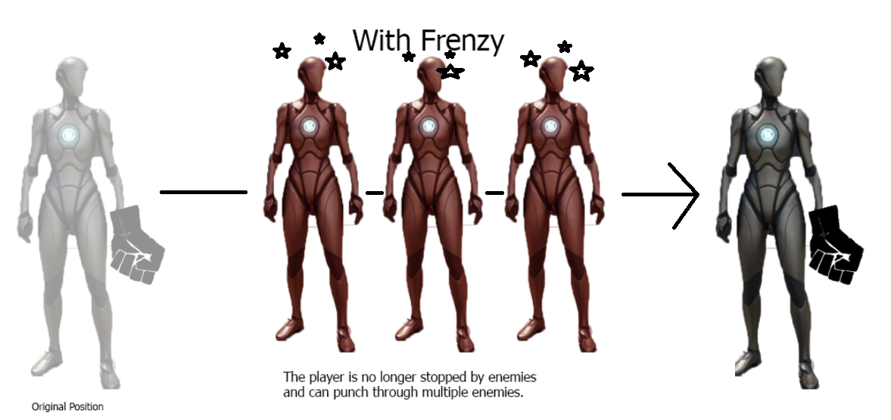

#### Anchor Vine

The Anchor Vine is the next action skill in our game and belongs to the second main level in which the player will have to navigate a jungle environment. When used, this action skill will launch forward a tether in the direction the player is looking which will travel a distance of 20m. If the anchor vine encounters a non-enemy obstacle within this 20m range then it will lock onto the impact point on that structure and begin to pull the player towards it at a speed of 10m/s. The player will be able to at any point disconnect the anchor vine by releasing the action skill button which will retain the player's current momentum allowing them to slingshot themselves around the map. When this ability is augmented by frenzy, it will enable the anchor vine to also grapple onto enemy units in the game, dealing 20 damage to them and freezing them in place while the vine is connected. Additionally, for a period of 3 seconds after the anchor vine impacts an enemy, all damage that enemy receives will be increased by 5 damage points.

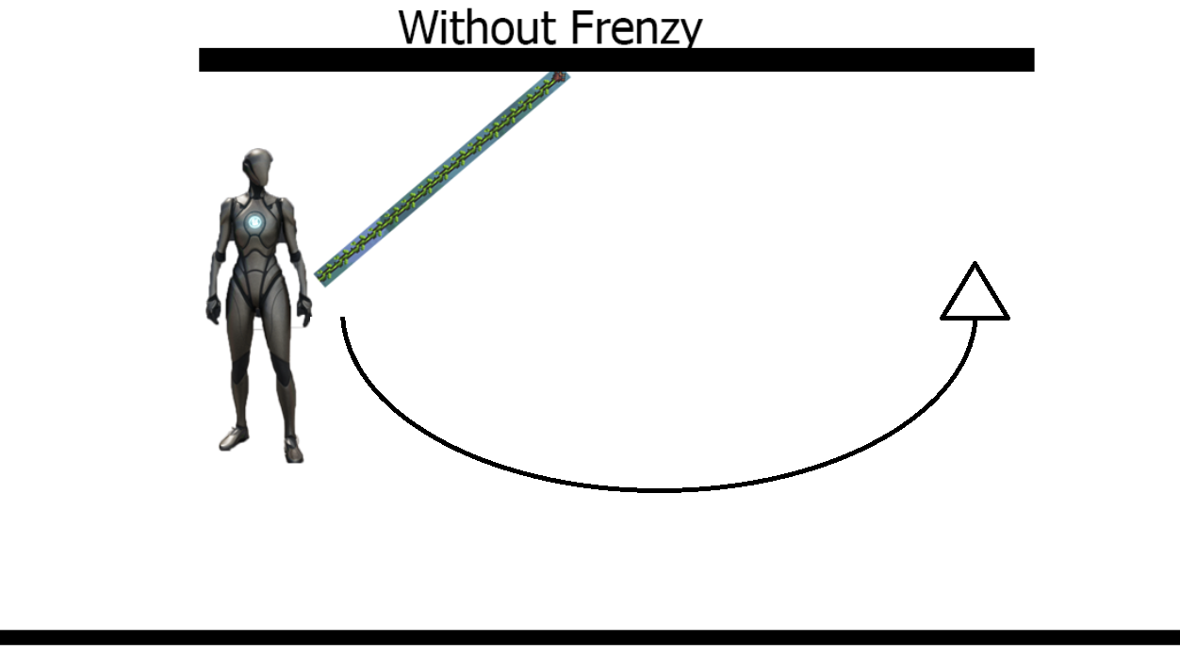

#### 

#### Ionic Blink

The second last action skill the player will have access to is called Ionic Blink. Ionic Blink will be the present action skill for the third main level in our game which will be set in a neon city environment. When activated, ionic blink will allow the player to teleport forwards in the direction they are facing for a distance of 10m or until they collide with a wall (but not an enemy). This when augmented by frenzy gains the effect of dealing 50 damage to any enemy between the starting point and end location of the teleport as well as having an effect where if an enemy is killed by this augmented ability, the ability will instantly be refreshed and the player will not have to wait for a cooldown to use it again.

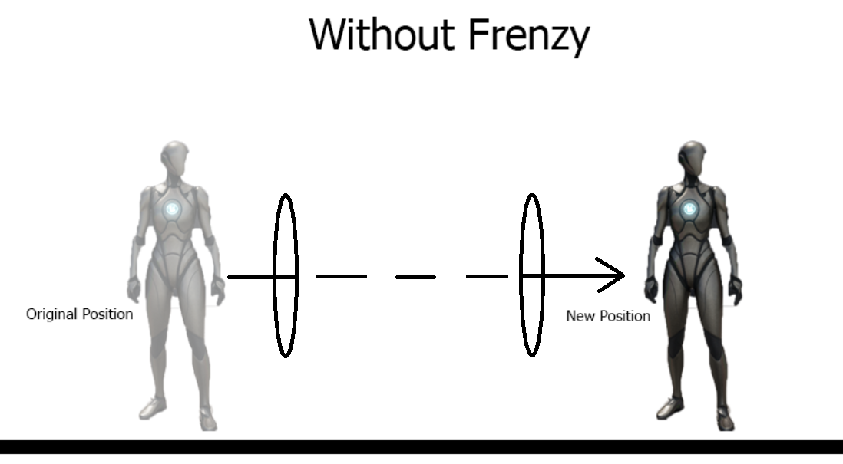

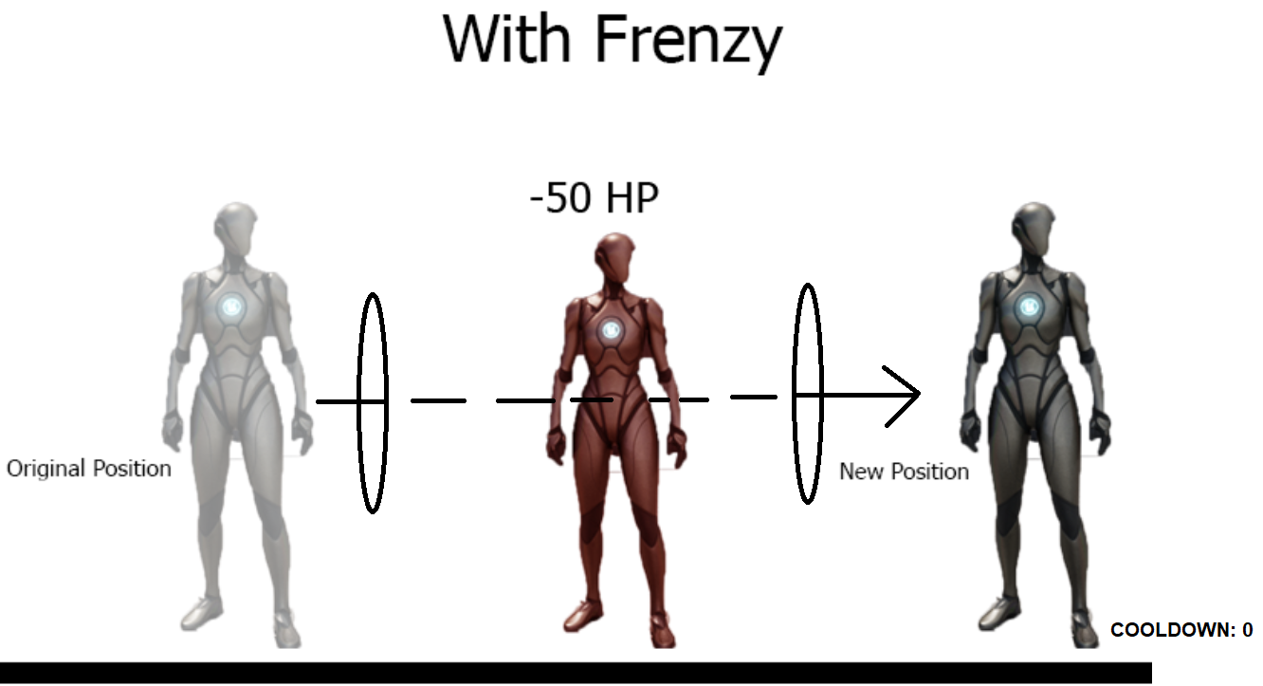

#### Seismic Leap

The final ability in our game is called Seismic Leap and belongs to the second last main level. This ability when used will launch the player in an arcing leap in the direction they are facing. This ability will also cause the player to emit a shockwave when they land which will deal 25 damage to enemies within a 4m radius around the landing point. This ability is further enhanced by frenzy as when augmented, the leap will travel a further distance and the area of effect damage radius from landing will be increased by 4m for a total of 8m. This effect will be further enhanced by leaving a lingering ‘aftershock’ effect on the ground at the landing location that will pulse once every second for a total of 3 seconds (3 pulses) that will deal an additional 25 damage each and slow enemy movement speed by 20% for all enemies affected.

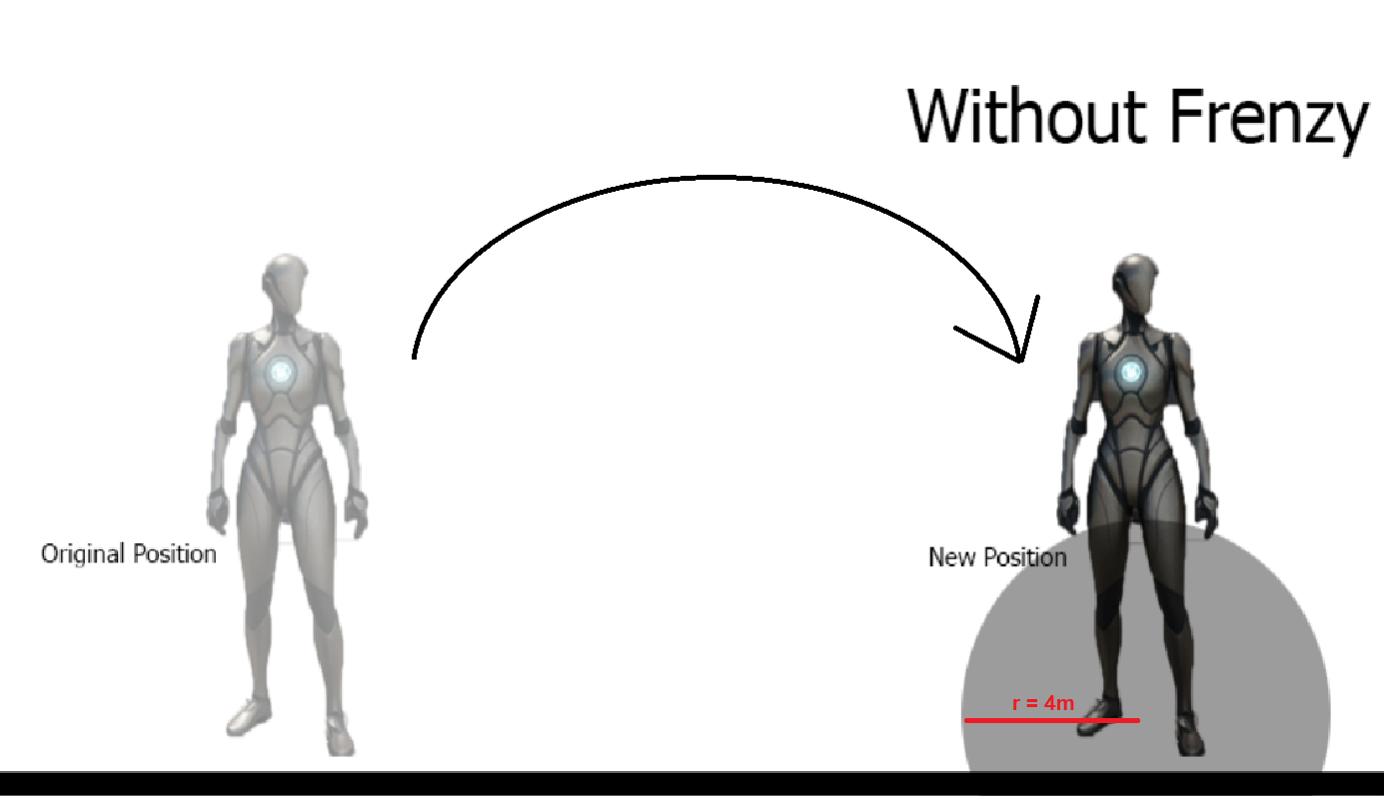

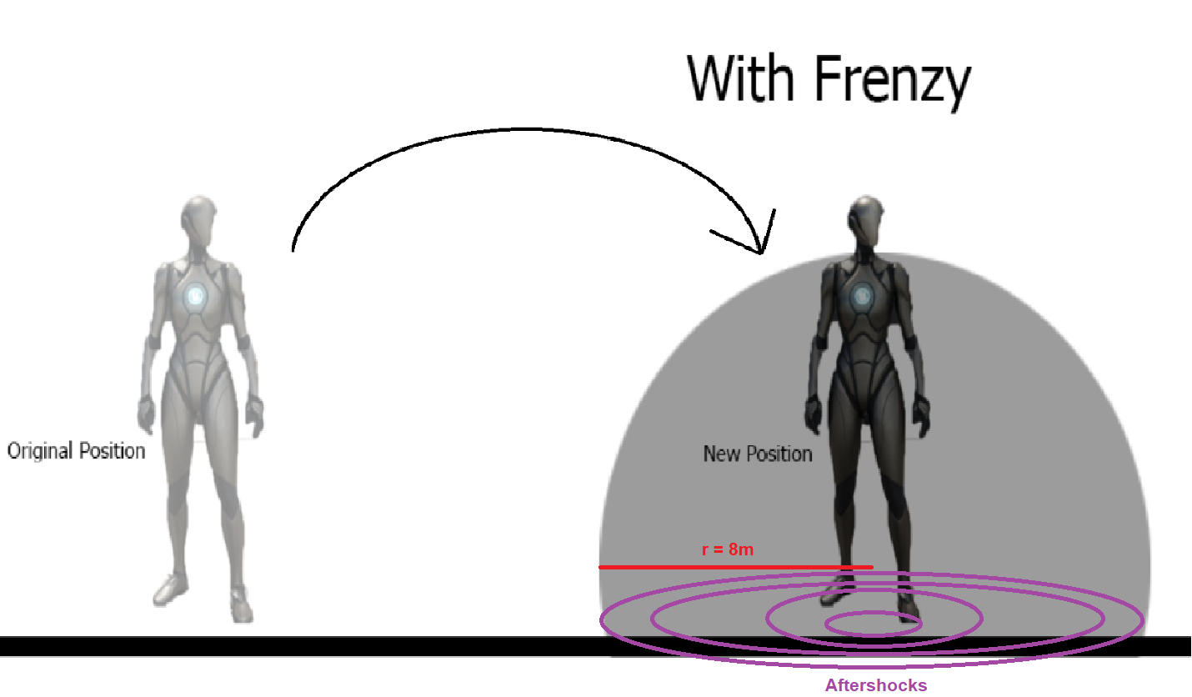

## Enemy Mechanics

An enemy for our first level will be a zombie that has the ability to throw its own head at you. After throwing its head, it will behave like a normal zombie that simply runs at the player, and upon making contact with the player, will start to damage them.

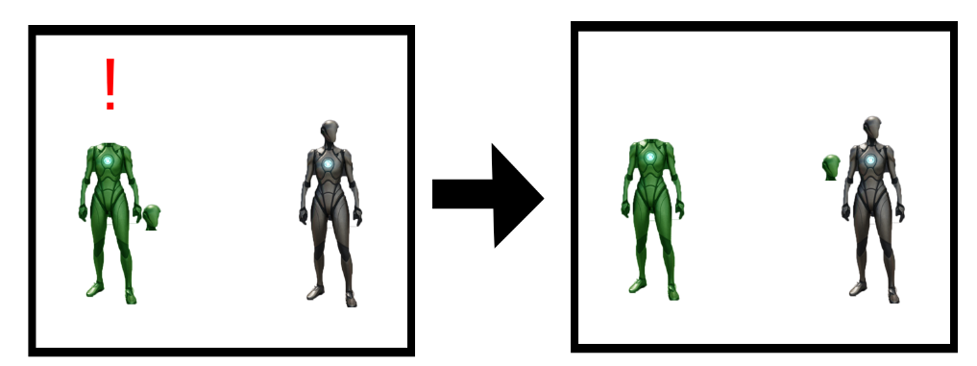

After this, the zombie will simply run at the player, causing contact damage.

For our second level, the jungle level, the enemy will have the ability to whip the player as a melee attack, impairing their movement with vines and thorns. The player must either kill the enemy, or button mash their way out of the vines through spamming different movement directions, which will free them from the vines.

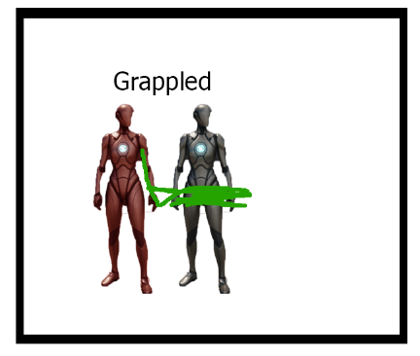

In the futuristic city level, the enemies will have the ability to shoot a Ray of Confusion at the player, which will temporarily make their screen “holographic”, somewhat duplicating a screenshot of their screen a few seconds prior. This gives the player an almost “drunk” effect, and can only wear off after a certain amount of time.

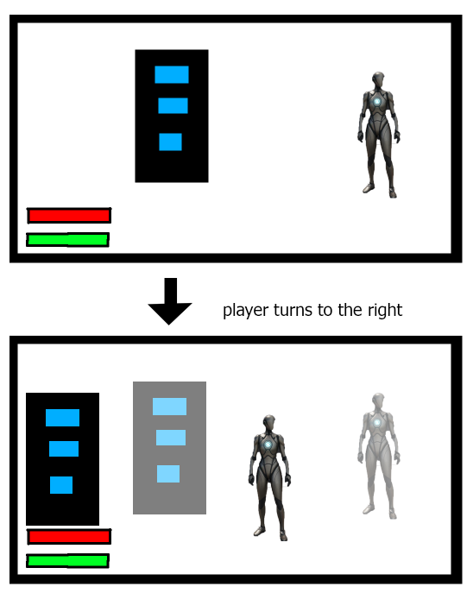

As seen, there’s an afterimage of both the building and the enemy.

While in space, enemies have the ability to shoot a mini-black hole at the player. This sucks them and any surrounding loose obstacles in, potentially causing them to get stuck and take heavy gravitational damage. Enemies will be unaffected. 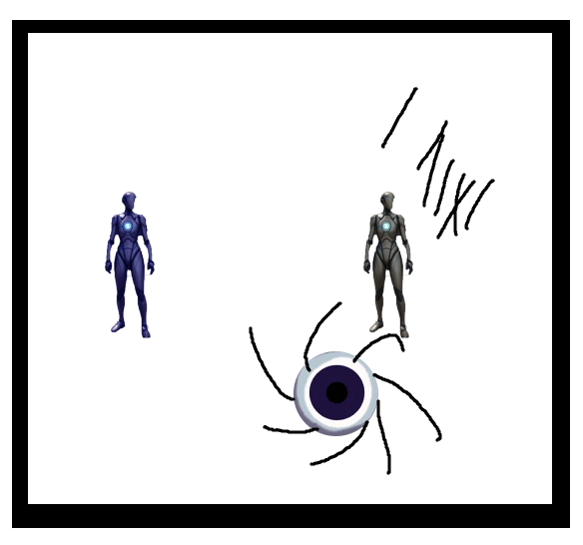

The player’s getting sucked in by the projectile shot by the enemy and is getting pulled in, while the enemy doesn’t get affected by it.

Our boss will have each of these abilities, apart from the head throwing ability from the Zombies. Instead, he will simply shoot out blobs of void at the player, which will essentially serve the same purpose. Additionally, vines, rays of confusion and black holes will be all a part of his arsenal. On top of this, it will have the ability to jump and create a huge shockwave, momentarily inverting the player’s controls and movement.

The boss will look more like a body-less-spark of light, instead of an actual humanoid.

Boss

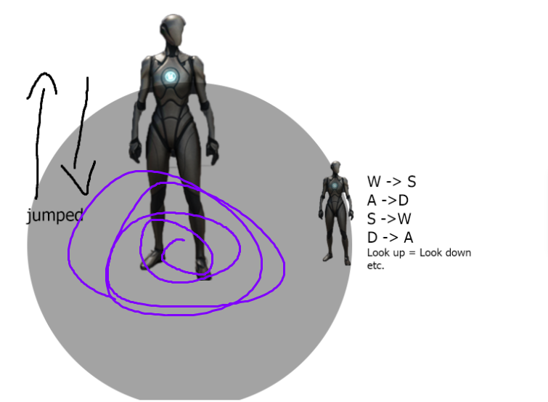

## 

## Other Game Mechanics

### Spikes

Some levels may include spikes objects. These are small pointy sections of flooring that cannot be destroyed, and if stepped on will damage the relevant entity. They are primarily traps for players, but they will also be able to damage enemies, so that players can strategically ‘bait’ enemies through spikes to hurt themselves. Spikes deal 20 damage to the entity stepping on it.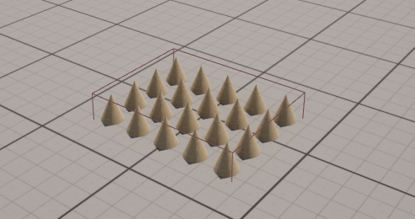

## Level transitions

As the player progresses through each level, they will have to fight their way through closed rooms, defeating enemies to unlock them. In the final room once cleared of enemies, the memory fragment will be unveiled from a shielded or otherwise unattainable area, and the player will be able to collect it by walking over it. This will trigger the end of the level, where a cutscene may play and the player will be transported back to the hub area. The player will then be prompted to place the memory fragment on the table in the centre of the hub by interacting with it, and upon doing so the door in the hub to the next level will unlock, with the barrier blocking it dissolving. The player can then walk through the new door to begin the next level, which will begin with a cutscene before the player ‘spawns in’ and enters combat.

## Ending game conditions

The final level, which will be the 5th main level, or otherwise the ‘boss’ level, will feature a non-standard encounter and objectives. Instead of the usual room-clearing sequence, the player will begin with a special cutscene, followed by the player chasing the boss through the level. In each room the boss will stop running, and summon a group of smaller enemies in the room that will attempt to overwhelm the player. It should be noted that the boss will not become immune from damage during this period as this may result in a less enjoyable experience for the player. Upon defeating the enemies, the boss will fight the player more directly, until it takes a certain amount of damage, upon which the boss will start running, and the sequence repeats 4 times with the level theme and player’s action skill changing in each section. In the final section, the boss will be defeated when its health fully depletes, and the final cutscene will play revealing the player’s memory pieced together by the final fragment that the boss drops. The screen will then fade to black and the credits roll.

# Level Designs

## Intro level

A hospital with 3 floors which included treasure hunts, jumping puzzles and enemy fighting. On the 1st floor, players will need to look for weapons and the key to open the door of the main treatment room on the second floor. Since there will be enemies wandering on the second floor, it is very important that players get those weapons and the key. There will be 6 rooms on the ground level, which were used to prison people with psychosis. Considering it is an abandoned psych hospital, all rooms will be empty with a bed and a washstand now. There is a reception area in the middle, between the stairs to the second floor. The key to enter the main treatment room is either hiding in those rooms or the reception area. Players can see there are doors on both sides too when they first walk in, but they won’t be able to enter those rooms, they are just for decoration. On the 2nd floor, there will be 4 zombies who were once a psycho patient in this hospital. They will be attacking players once you enter their attacking zone. The way they attack is by throwing their heads, which means they have their heads on their hands all the time. The setting for those zombies is that they are the failure of an experiment, so the right side of their chest will be empty and players can see their sternums. The purpose of why those zombies are there is to slow down or even stop players from entering the main treatment room. There will be some better weapons and equipment in there for players to collect, even a hint to help players to analyse the memory fragment on the 3rd floor. So it is very important that players find the key and beat those zombies. As the main treatment room will be on the left side on the 2nd floor, on the other side, there will be a jumping puzzle to get players to the 3rd floor. When players enter the jumping puzzle room, they will see how broken the whole room is, this suits the “abandoned” element in the narrative. The ceiling of the room is broken down and there will be some objects to get players to “jump” to the 3rd floor. The final boss of this intro level will be there. The final boss is a mutated experimental failure. Compared with the zombies on the second floor, he will be larger and more ferocious in appearance. The 3rd floor is an open ground, which will not limit the player to move around and dodge the attacks. Players need to beat the boss to get the memory fragment, in order to cure the patient in real life. In addition, players should use their skill (combat stim for this level) wisely to help them defeat bosses better.

## 

## Hub

Hub area in our game is a hexagon room with 5 doors and a table. The player can choose different doors to enter different memories and collect different memory fragments. The player needs to put the memory fragments on the table to view it.

## Level 1

This level will take place in an area covered by the flesh meat, players starting in a tunnel and need to go through a jumping puzzle. The player will need to reach the temple area in this map to get the memory fragment for this level.

The Player will need to pick up an artefact near their spawn point and this artefact allows the player to use the punch ability in this level. The player can use the punch ability to move and attack enemies. Punch can do the damage to enemies and push them away, which is really useful when the player has to face a lot of enemies in one room.

Then players will be attacked by a bunch of enemies, the general enemies in this level are still the normal zombies from the Intro level, but there will be more of them this time, so players will definitely be more careful while dodging their attacks. There will be some models of flesh meat on the wall to make this scene more like a meat area. Players can look around but won’t be blocked or attacked by meat. While players are on the way toward the temple led by Sparks, the enemies will come out and attack again, which players will need to be cautious about. On the way to the temple, the player will also need to face 2 different kinds of enemies. Which are the no head zombie and flash zombie. No head zombie can throw the head to the player just like those in intro level, and flash zombies can flash the player for 2 seconds to interrupt the player’s attack.

The final boss of this level will be in the temple. The setting of this boss will be the leader of all the creatures in this twisted world, it will be a wolf shaped enemy, but much larger in size compared to zombies. However, the boss will have stronger forelimbs. In the design part, we will make its forelimbs larger and add some new moves of attack to it, and of course it will have much higher damage compared to the normal enemies.

Since the boss is much stronger, we prepared a new equipment for players, a shield capable of resisting boss attacks. Although this shield is a great buff towards players, it has its durability. After being attacked by the boss 8 times, the shield will be broken and cannot be used anymore. Thus, players will need to find the second useful supply in the temple, a dynamite. As the normal guns and pistols that players have will deal enough damage to kill the boss, this dynamite can easily defeat the boss and put it into a dying state. Players then can finish up the boss and get the memory fragment. The important part in this level is that players will need to look for the dynamite while attacking the boss with their regular weapon to slow the boss down.

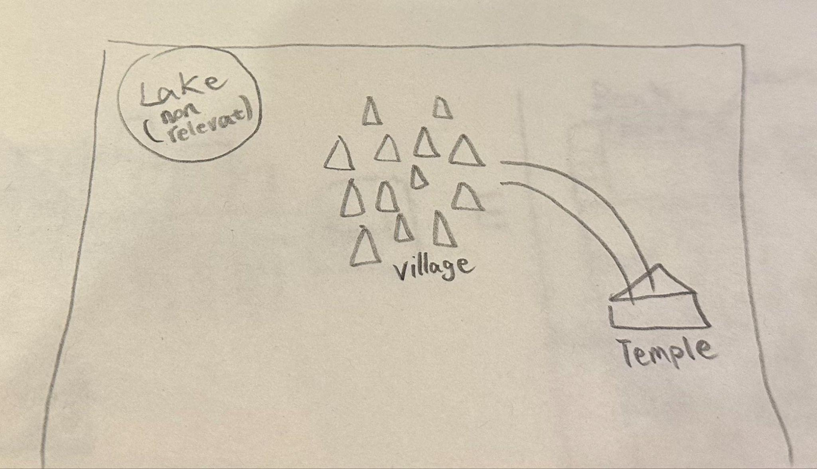

## Level 2

In this level, players will need to cross a dangerous jungle area to reach a building, find the useful documents there and finally finish at a ruin with a giant guarding the important memory fragment. All the weapons and equipment that players need are all in the house where players spawn at. After picking up everything needed, players will enter a jungle area full of zombies attacking with vines and thorns, and the classic no head zombies! We plan to model 3 tree meshes and some plants as the prototypes and make a jungle by duplicating, transforming and rotating to make a jungle. Once players reach the building, there is no enemy in there. But players need to collect all the documents and clues to help them analyse the memory fragment. The building will have 2 floors, each floor has the same floor plan. There will be few rooms and a corridor. After players find everything they need, they will be headed to the final scene of this level, the ruin. I plan to make the ruin not very far away from the building, between them will be a small jungle area too. The boss of this level will be a giant that has a super high defence and a lot of HP. The ruins will be made up of many giant stones, players will need to keep running to dodge the attacks by the giant and find a rocket launcher and aim the giant’s head. After players kill the giant, there will be a key pop out, then players will need to check the map again and find a secret door in the ruins. The design position of the door will be below ground level. After players open the door, they will get the memory fragment for this level and tp back to the HUB.

## 

## Level 3

For level 3, our game will take place in a futuristic city. Players will spawn in a room in the city first, there will be a futuristic-looking sniper rifle in the room which players will need to pick up and it will be useful in this level. There will only be a desk inside the room. After players get out of the room, they will find that they are in the south west corner of the city, and Sparks will remind players to head to the east side of the city because the memory fragment of this level might be inside the central vault which is landed at east of the city. As this is a very prosperous city, we will not only design and create many buildings around the map, but also put bunches of Neon lights on every building to make sure the city is lively enough. We plan to create some more human models alongside the enemy models, they will be placed everywhere inside the city. However, players are not able to interact with those “citizens” in this city. The enemies in this level will be the guards of this city, they will have the ability to shoot a Ray of Confusion at the player, which will temporarily make their screen “holographic” as mentioned above in the “Enemy mechanics” part. For the appearance of those guards, they will just wear like the “special operations group” in real life but with more advanced and techy armors and weapons. There will be many guards patrolling the streets. Players will need to take them down and find the key to enter the bank where the vault is from a commander of the guards, he will be dressing a little bit differently compared to normal guards. Once players enter the bank, there will be 2 floors underground, the key only can open the doors for the ground level and the first floor, that means players will need to follow the manager into the vault down there on the lowest level. The manager will look just like the citizens, but with a special colour of coats. The first level of the bank will be the reception, there will be some rooms on both sides when entering the bank but won’t be able to get in. The first floor underground will be the place that many guards are guarding, there will only be one way to get down to the second floor underground. The structure of the first floor is a place with many rooms and a narrow corridor in the middle which leads to the second floor underground. Although there will be bunches of guards on the first floor, as players have the uniform from the commander, those guards will not attack you, so the goal for players is to find the manager. On the level of the vault, which is the second floor under ground, players need to hide well to make sure the manager doesn't see you until he opens the vault’s gate, because the key from the commander does not have access to the vault, it only allows players to open the gates to go to the underground levels. There will not be a boss in this level, but the amount of guards is expected to be more than any levels before.

## 

## Level 4

For our level 4, players will be headed to the moon. The terrain will be quite easy, which will be similar to a desert terrain but with some craters, and the colour will be close to silver grey. The only building in the map will be the base where players start at, and only inside the base, the gravity will be the same as earth, all other areas on the map will have a much lower gravity. With lower gravity, it allows players to jump 3 times higher but will be moving slower. For the mission in this level, players need to jump into a big hole where the memory fragment is. Players will take no damage on jumping from very high due to the low gravity. There will be 4 levels underground, B3, B5, B10 and B12 (from first to enter to the lowest). B3 will be the level where all the enemies are at, the enemies on the moon will be some aliens look-like creatures with special guns, and they will have the ability to shoot a mini-black hole at the player. This sucks them and any surrounding loose obstacles in, potentially causing them to get stuck and take heavy gravitational damage as mentioned above. There won’t be too many objects in B3 as well. Then players will be able to enter B5, where they can replenish ammunition. There will be a door in B5, but it’s locked so players will not be able to interact or go through the door. B10 will be a “treasury hunting” type of area, Players will need to find a key that can open the gate in B12 to finally get the memory fragment. There will be some enemies in B10 as well but a bit less than B3. The scene of B10 will be a corrupted area, so we will make some meshes like corrupted machines and biological remains. The key will be hiding inside a machine. There will only be a gate in B12, where the memory fragment is inside, after players collect the fragment, they will be teleported back to the HUB, there’s no boss in this level as well. And for the design of how the gate will look, we plan to make it the same as the door that players got in to get to the level 4.

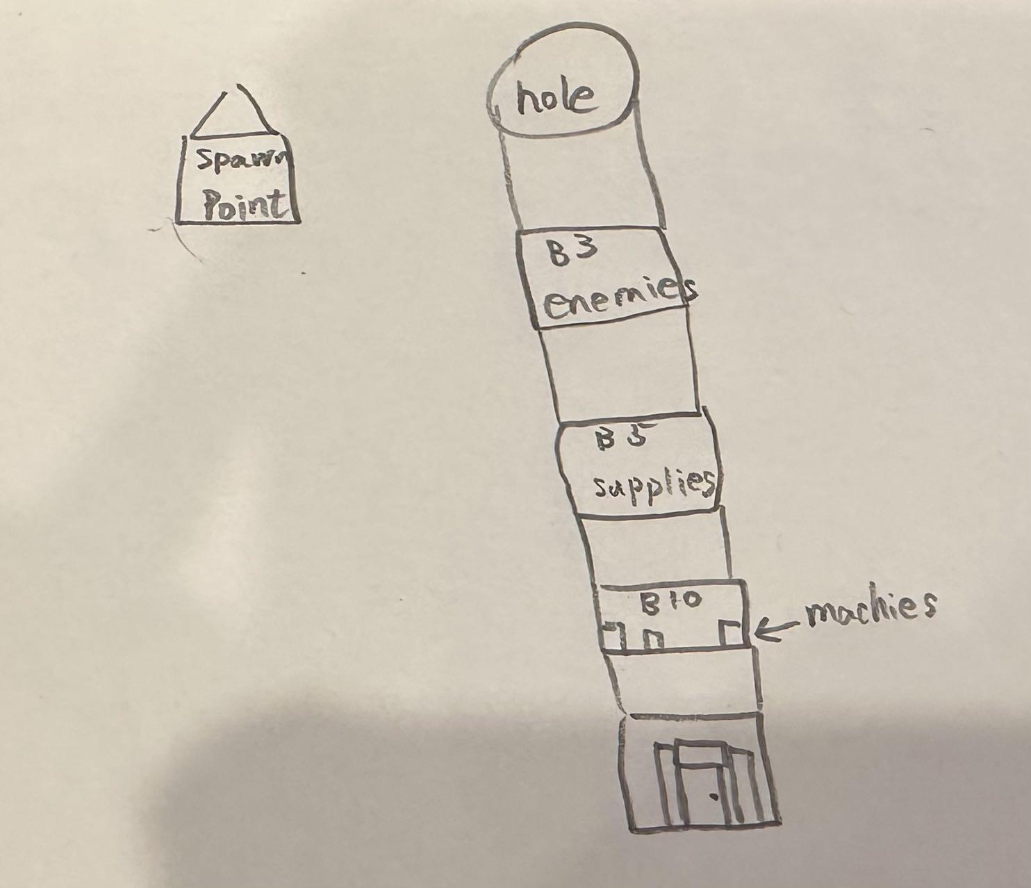

## Boss Level

Chase the boss through sub-areas following the themes of previous levels, in each section the player gets to use the ability they had in the relevant level. Beside that all of the terrains will be the same, the main enemy will be Sparks. Most of the previous enemies will disappear, however, Sparks has the ability to summon enemies. Most of the time will be the original enemies from every level, but there will be new enemies that only Sparks can summon to try to kill players, the shadow creatures. We plan to design this creature in a simple way. Since the amount of them will be huge, each of them will be quite small. They will be bat -like in shape, but their whole body in black. For the true form of Sparks, will just be a shadow. The true form of Sparks will have each of these abilities, apart from the head throwing ability from the Zombies. Instead, he will simply shoot out blobs of void at the player, which will essentially serve the same purpose. Additionally, vines, rays of confusion and black holes will be all a part of his arsenal. On top of this, it will have the ability to jump and create a huge shockwave, momentarily inverting the player’s controls and movement as mentioned above in the enemy mechanics session.

# 

# UI Design

## Menus

Our game will have 4 total menu screens that the player will be able to interact with, these will consist of the main menu, which will appear when the player first loads up the game. The options menu, where the player will be able to adjust and tweak the game settings to better fit their needs. The load/new game menu, which will allow the player to load a previous save or start a new game. And finally the in game pause menu, which will allow the player to pause their game and navigate back to previous menu options.

#### Main Menu

The main menu for our game will consist of a background image which will show a small preview of the theme of the game as well as the main theme music track that the game will use when the player is in combat set to a lower volume. The main menu will consist of 4 buttons that each serve their own purpose depending on what it is the player wishes to do.

* The first menu button will be the Play button and will appear as the top leftmost button which will also be significantly larger than the other buttons on the main menu screen. When pressed the play button will take the player to the load/new game menu in order for them to decide on how they want to play.
* The Second button on this menu will be the Options button and will appear just below the play button. When pressed, this will take the player to the options menu where they will be able to adjust their settings to fit their needs.
* The third button on the main menu will be the Quit button and will sit at the bottom left of the screen. When pressed this button will exit the application.
* The final button will be sitting in the bottom right of the screen and will be the Credits button. When pressed this button will take the player to a credits screen where they will be able to view who the game was made by as well as a list of external resources used in the games creation. The credits button is set away from the rest of the buttons because it is considered not relevant to the gameplay and as such we wanted it to be dissociated from the gameplay related buttons.

#### 

#### Options Menu

The options menu for our game will consist of a transparent background which will take from whatever background the previous menu was using. The reason for this is because the options menu is accessible from 2 different menus with different backgrounds so to make the menu transition feel seamless, the options menu will take its background from its previous menu. The menu will also be broken up into 3 main sections.

* The first section will be dedicated to graphics and performance settings. This section will include 4 different settings
  + Window mode
  + Vsync
  + Screen resolution
  + Graphics quality.
* The next section will be focused on the player controls and keybindings. This section will have a section where the player is able to change the keybindings for each control. Default keybindings for each control can be found under the Controls subhead of the Core Mechanics & User Interaction section. The player will also be able to adjust the mouse sensitivity settings under this section as well.
* The final section of the settings menu contains the settings dedicated to audio and will include a master volume slider, as well as individual volume sliders for both in game sound effects and music.

#### Load/New Game Menu

This menu will appear directly after the player selects the Play option from the Main menu and will consist of the same background and music as the main menu does. This menu’s purpose is to allow the player to select how they want to play the game. This will include 2 buttons, the New Game button and the Load Game button.

* When the player selects the New Game option, a fresh instance of the game will begin to play with zero player progress made which will allow the player to enjoy the full story of the game from the beginning.
* The Load Game button will instead take the user to a menu which will list the saved games stored on their machine and allow for them to select one to load. When loading a game from a previous save, the player will be placed into whatever point in the game's story that game save last played, meaning that returning players will not have to repeat missions they have already completed if they do not want to.

#### 

#### Pause Menu

The pause menu is the final menu and differs from the previous 3 menus as it does not appear before the game but rather during it. The pause menu can be accessed via pause keybind [P] at any time during gameplay. When the keybind is pressed, the game will pause and the menu will appear containing 4 options.

* The first option will be the Resume option which will unpause the game and hide the pause menu when selected.
* The second option is the Options button and will take the player to the Options menu and allow them to modify their settings if they need to.
* The third option is the Exit to menus option and will save the current game and then return the player to the main menu.
* The final option is the Quit button and will cause the game application to close after saving the game.

## In Game

The in-game user interface will be a heads-up-display, common for first person shooter games. This will quickly provide essential information to the player where they expect it (as it follows conventions from other FPS games), and contains the least obstruction to the player’s vision while doing so, allowing them to focus on their surroundings in the middle of combat.

The HUD will feature the player’s health and frenzy in both bars and numbers in the bottom left corner, so they can check at any time how close they are to dying and alter their playstyle or strategy to suit. The frenzy will also help them plan their powered ability usage, as well as check how much movement speed bonus they have. The player’s current objectives will feature in the top left corner, which they can check at any time to remind them of what to do if they ever feel lost, and to highlight to them when they complete an objective and are able to move on to the next. Their current weapon, ammo and ability cooldown will feature in the bottom right corner, so they can glance at it mid-combat as expected in any FPS to check essential information and play accordingly. The crosshair in the centre of the screen is arguably the most important part of any shooter game, and will significantly assist the player to aim at the targets they want to attack.

